### Lab 1

Name: Eduardo Wang Zheng

E-mail: eduardo@sjtu.edu.cn

1. Requirements
2. Create a scene in **Unity**
3. Use **Unity Shader** to make a mirror
4. Use **Unity Shader** to achieve transparency
5. Use **Unity Shader** to realize Gooch Shading
6. Experiments
   1. Create a scene in Unity

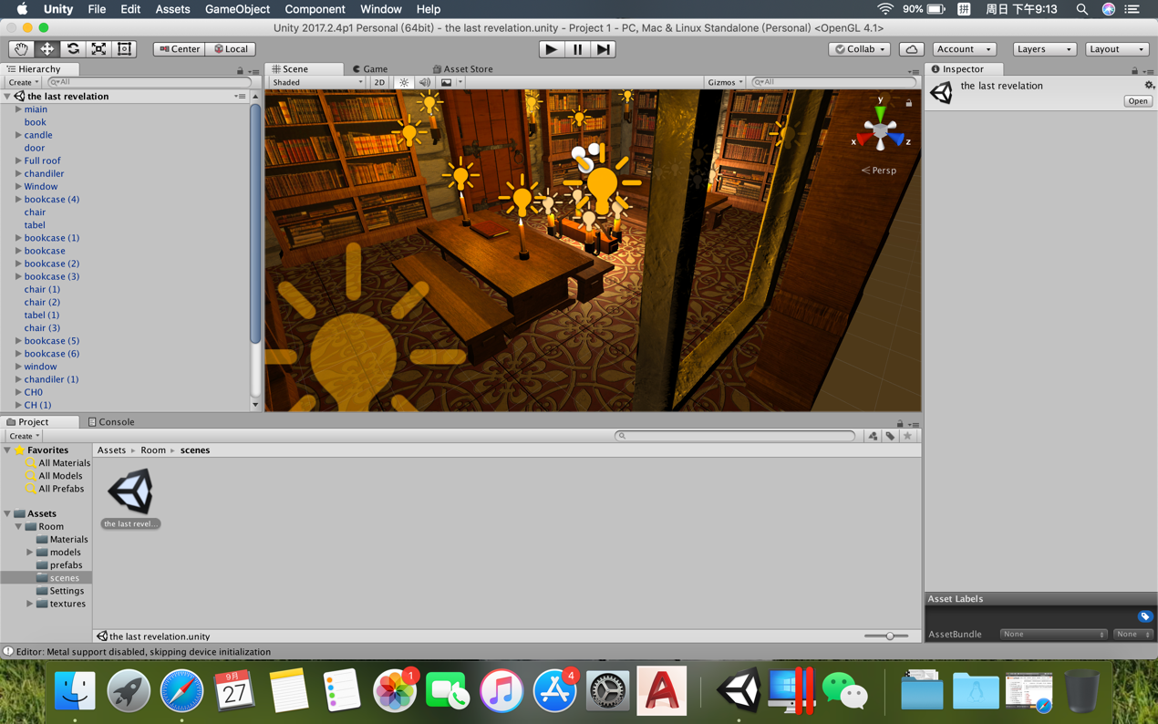

* 1. Use Unity Shader to make a mirror
     1. Difficult points and solutions

1. Using reflection texture in **Unity Shader**



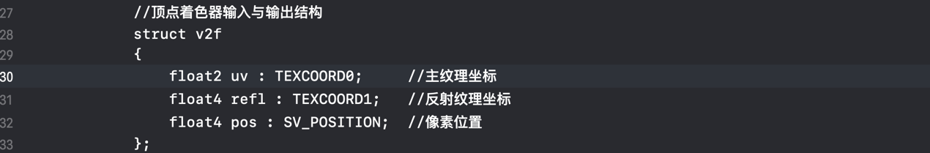

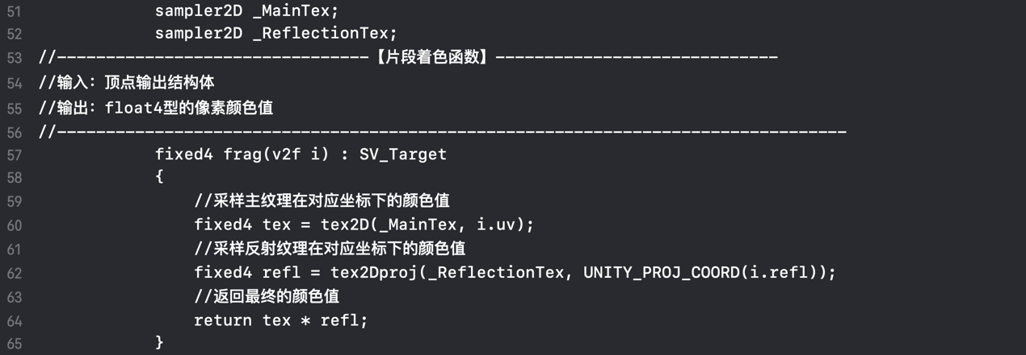

2. There are many details in the C# script. I only list out the key part for convenience.

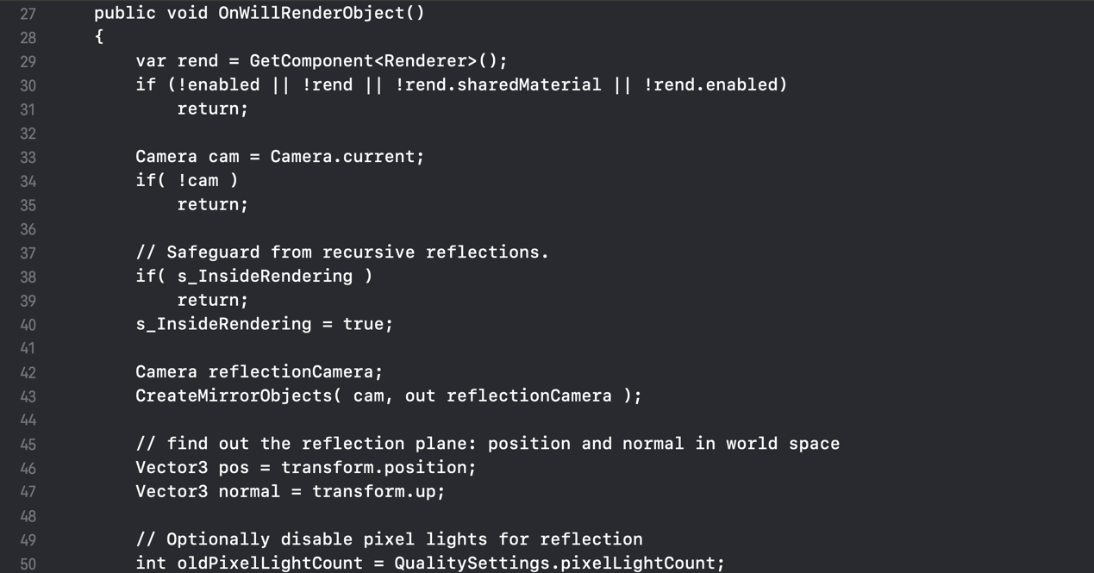

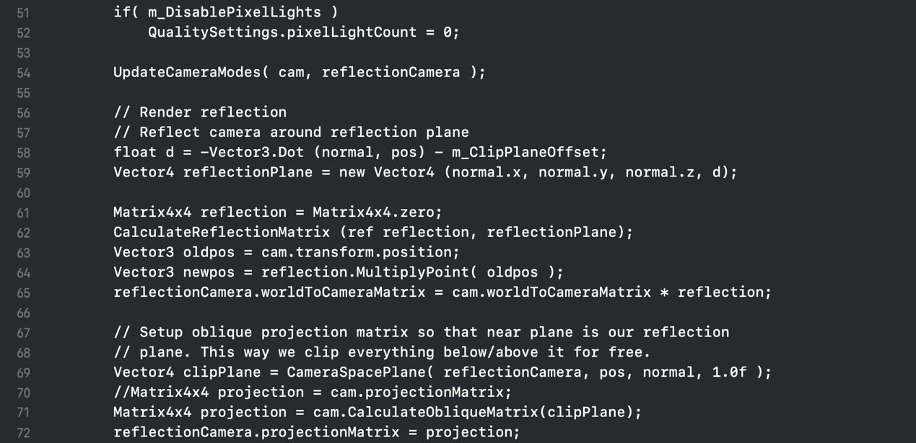

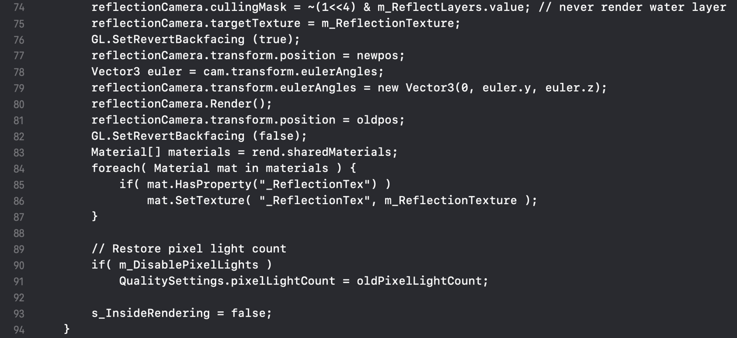

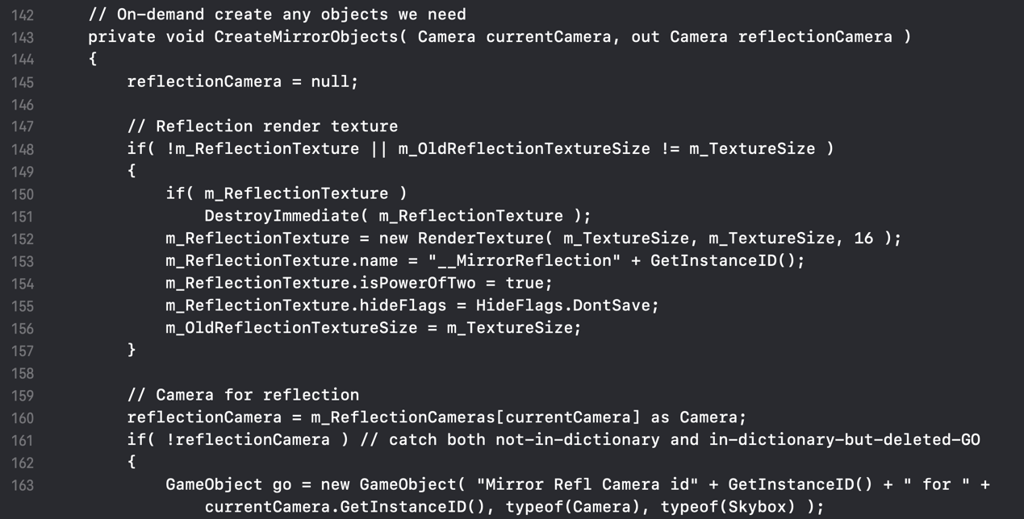

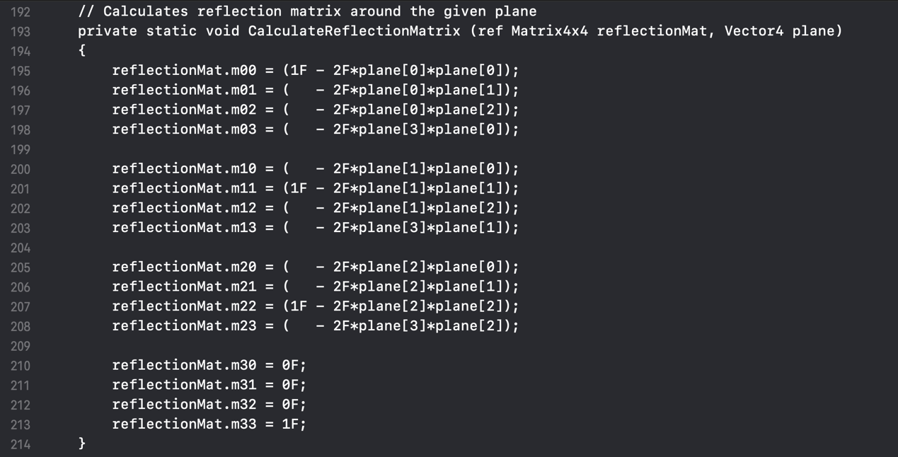

* + 1. Evaluation

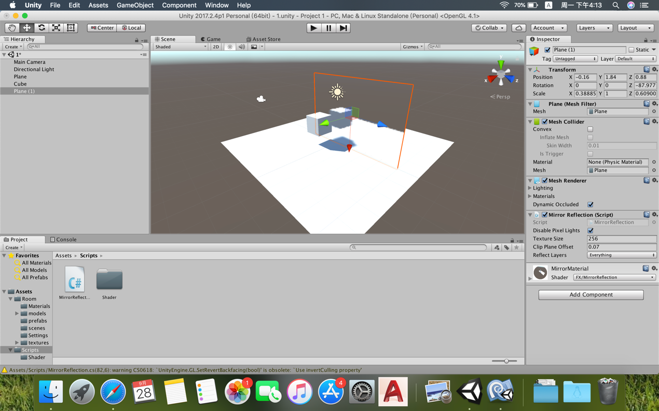

* 1. Use Unity Shader to achieve transparency
     1. Difficult points and solutions

1. Using **Fresnel reflection and refraction** in **Unity Shader**

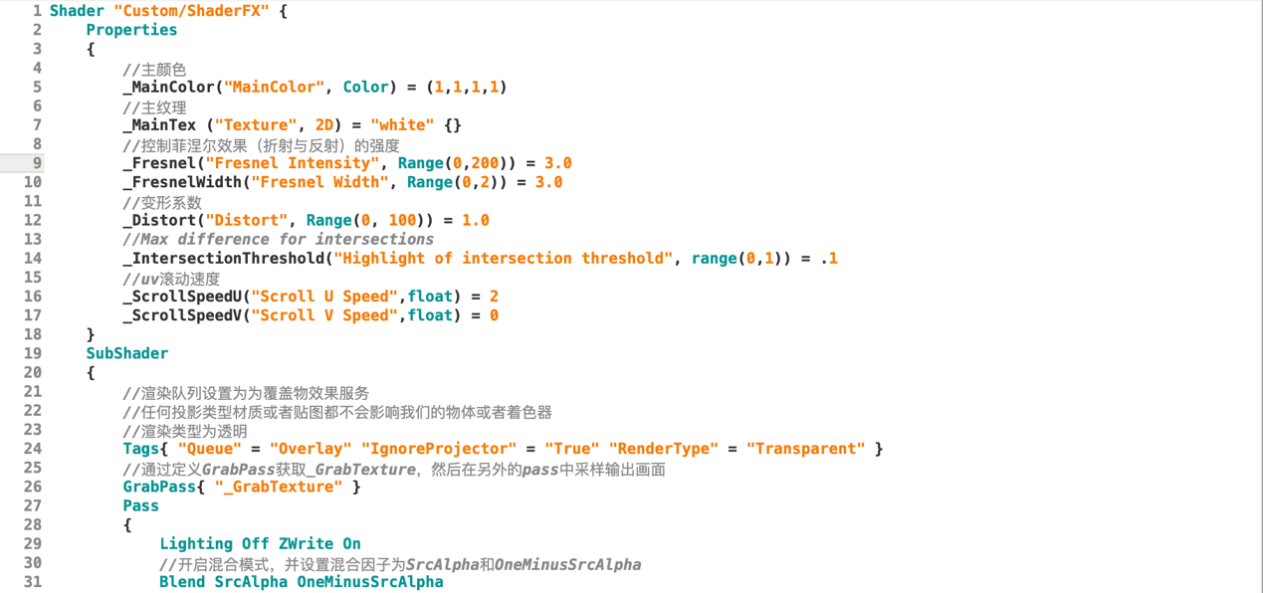

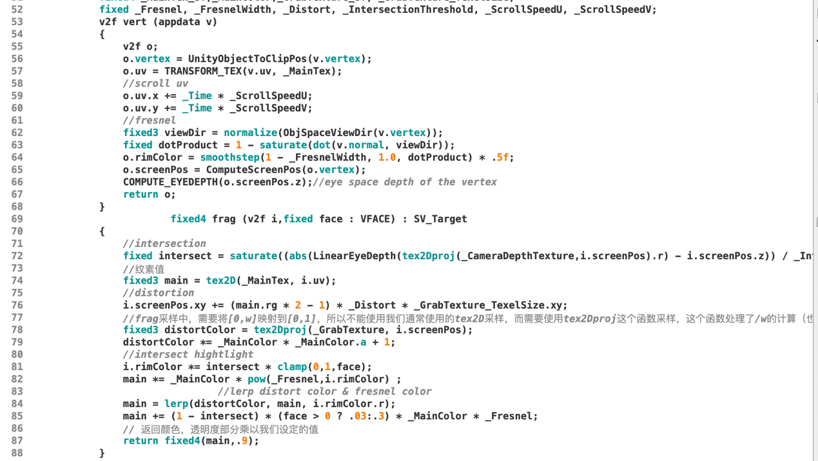

* + 1. Evaluation

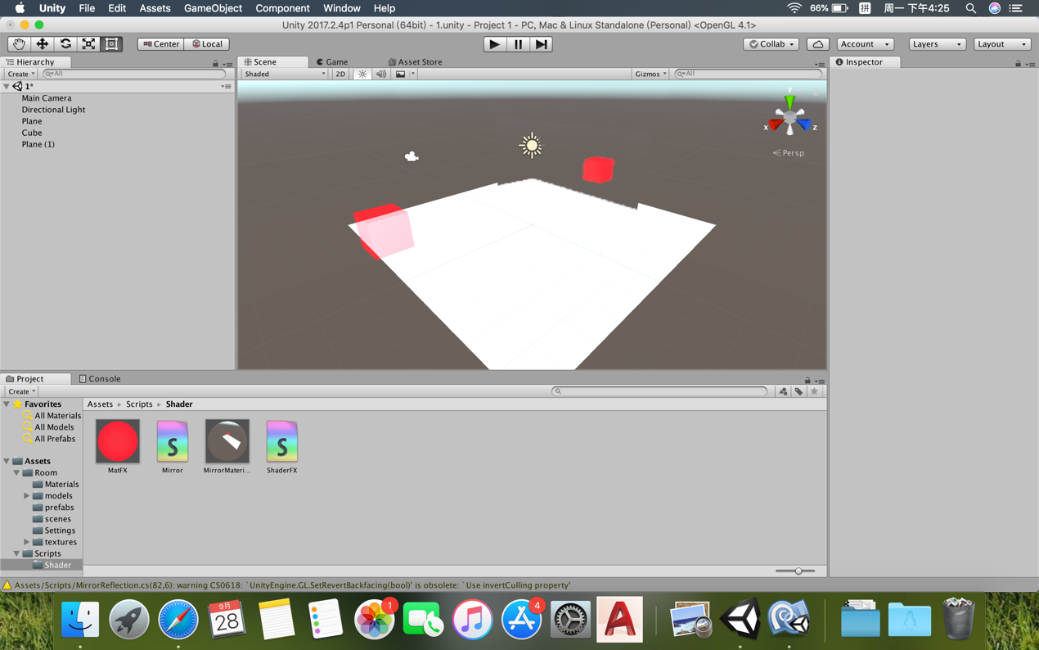

* 1. Use Unity Shader to realize Gooch Shading
     1. Difficult points and solutions

Compared with the above two requirements, realizing **Gooch Shading** in **Unity Shader i**s easier:

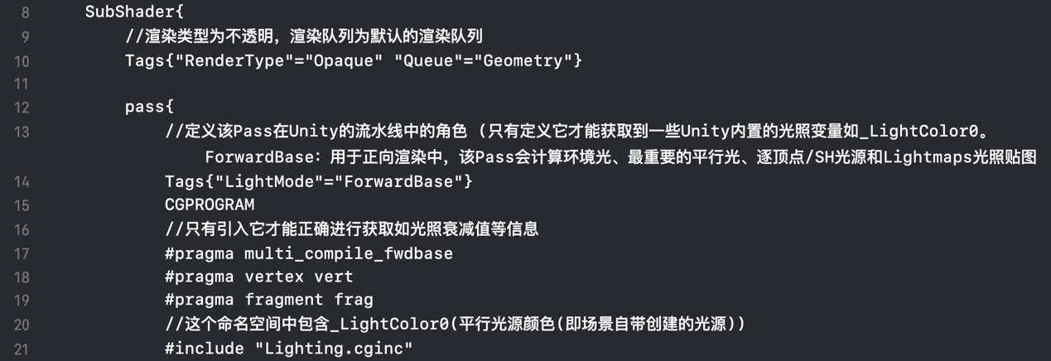

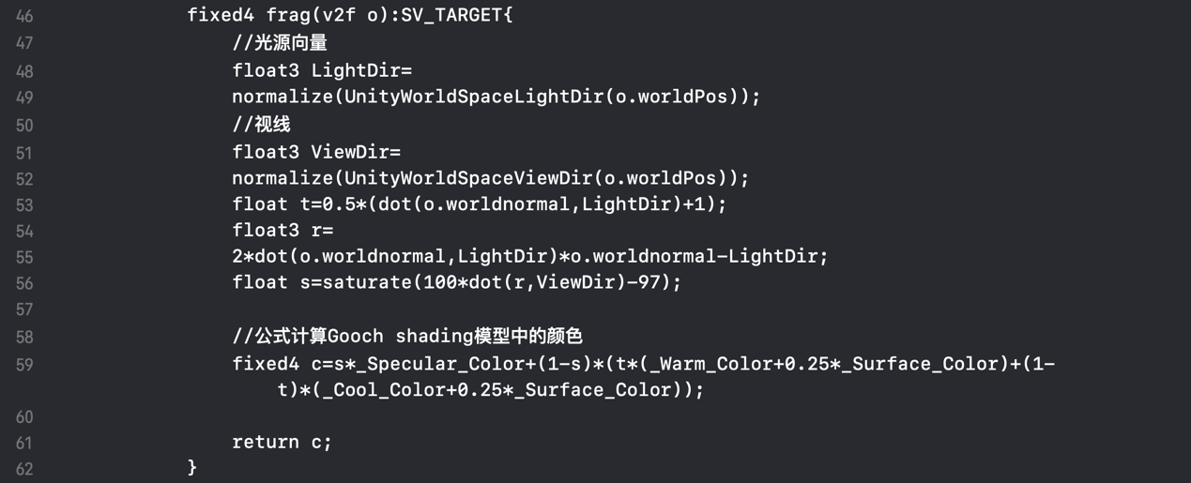

* + 1. Evaluation

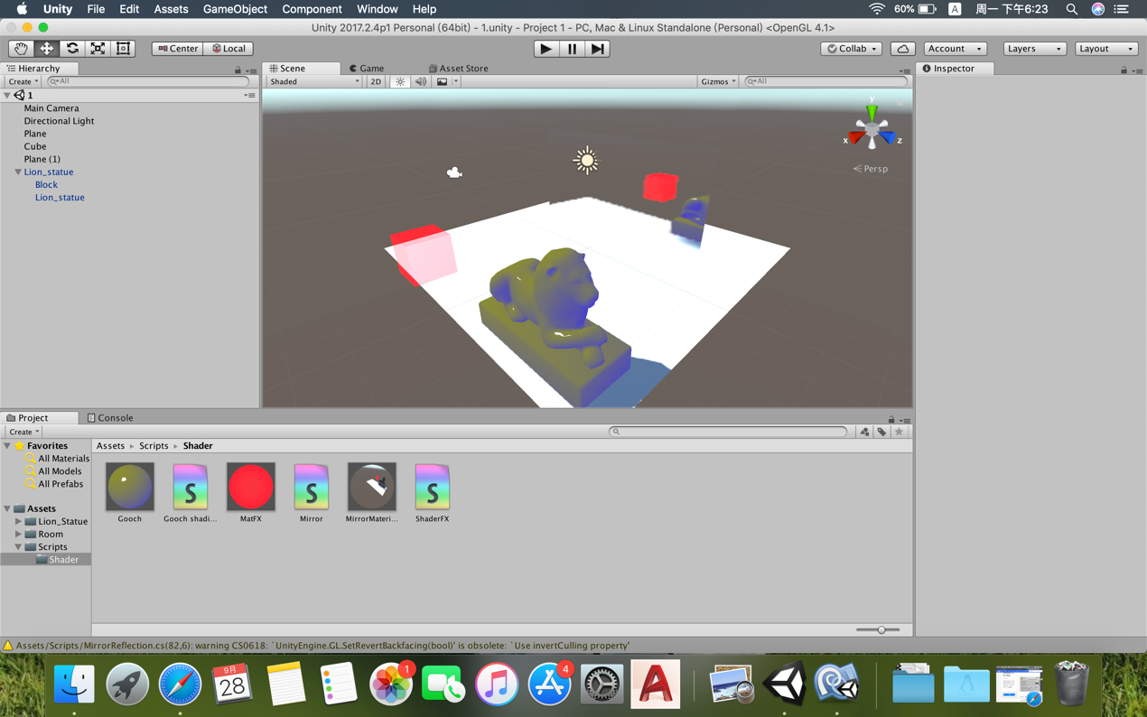

1. Achievements
2. Master some basic operations in **Unity.**
3. Learn how to edit **Unity Shader** to make a mirror, achieve transparency and realize Gooch Shading.
4. Learn how to edit C# script and use it to make a mirror.